Analyzing Trends of Gun Violence in District 4 in the City of Boston

Team 3

Sarah Bonna (Team Lead) Brian Mahabir Shivangi Showndarya Madhavan

[sbonna@bu.edu](mailto:sbonna@bu.edu) [bmahabir@bu.edu](mailto:bmahabir@bu.edu) [shivi09@bu.edu](mailto:shivi09@bu.edu) [shmadhav@bu.edu](mailto:shmadhav@bu.edu)

GRS'23 ECE’23 GRS'23 GRS'23

CS 506 Tools for Data Science

14th April 2023

# 

# Introduction

## Background

Boston's District 4 comprises the neighborhoods of Dorchester, Mattapan, and parts of Roslindale and Jamaica Plain. According to data from the Boston Police Department, there were 75 shooting incidents in District 4 in 2021, which is an increase from 2020. Moreover, gun possession among youth in the district has also increased, with many young people carrying guns for protection or as a status symbol.

To understand the project, it would be helpful to know the factors contributing to gun violence, such as poverty, access to firearms, mental health, and social dynamics. Familiarity with the existing programs designed to address gun violence, their effectiveness, and their limitations would also be helpful.

## Motivation

The recent increase in gun possession among youth in Boston's District 4 has raised concerns about the community's safety. To address this issue, it is necessary to understand the root causes of gun violence in the district and the city. This will allow for informed policies that can improve the district and reduce the incidence of gun violence.

## Goal

Gun violence is a significant public health and safety issue in many cities, including Boston, Massachusetts. Boston's District 4 has been particularly impacted by gun violence, with high rates of shootings and homicides. We want to understand the drivers of gun violence in Boston's District 4 and the city as a whole, focusing on identifying the variables associated with increases or decreases in gun violence.

# Base Analysis

## 

# Section 1 What is the rate of gun violence in District 4? How does this compare to the rest of the city?

### Section 1.1 Number of Gun Violence Incidents in Each District for Each Year

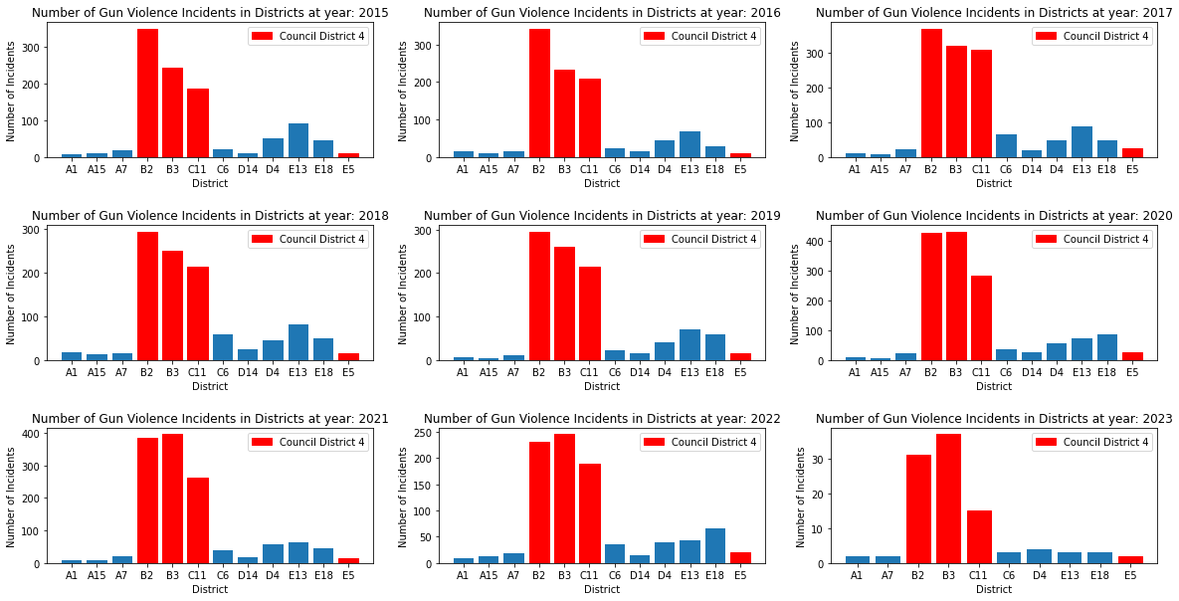

Fig. 1 Number of Gun Violence Incidents in Each District 2015 - 2023

Figure 1 shows the number of gun violence incidents per year for each police district. Colored in red are the police districts inside the council city district 4. We found that all the districts associated with council city district 4 have the highest rate of gun violence compared to the rest of the districts. The trend of gun violence in each police district every year is relatively unchanging. This showcases that gun violence is not inherently dependent on the timeframe.

### Section 1.2 The Ratio of Gun Violence Per Year (District 4 vs. Rest of Boston)

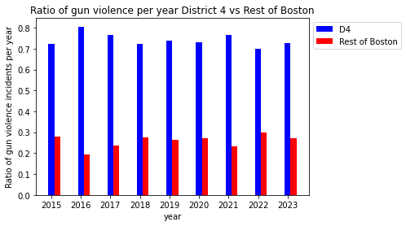

Fig. 2 Ratio of Gun Violence (District 4 vs. Rest of Boston) 2015 - 2023

Figure 2 shows the ratio of gun violence incidents per year for District 4 versus the rest of Boston. Colored in blue are the police districts that form District 4. As seen in the figure above, District 4 has the highest ratio of gun violence every single year from 2015 to 2023. The disparity in the ratio of gun violence between District 4 and the rest of Boston ranges from slightly more than twice to slightly more than 4 times. The highest ratio of gun violence occurred in 2016, with 80% of gun violence in that year occurring in District 4. In 2023 alone, 70% of gun violence thus far occurred in District 4.

### Section 1.3 Number of Incidents by District and Race

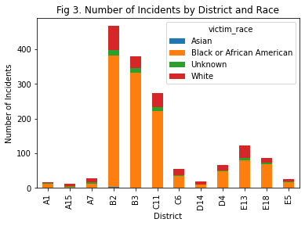

Fig. 3 Number of Incidents by District and Race

The above-stacked bar chart shows the number of incidents per district and victim race. Each district is divided into segments representing the number of incidents for each victim race. Black or African American people are disproportionately affected by shooting incidents, with significantly higher numbers than other races. Unknown ethnicity victims are present in relatively high numbers, indicating a need for improved reporting and data collection methods.

Incidents involving Asian victims are almost negligible.

### Section 1.4 Percentage of Shooting Incidents by Victim Race

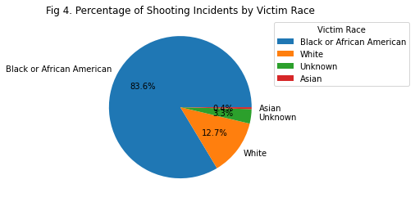

Fig. 4 Percentage of Shooting Incidents by Victim Race

In District 4, most shooting incidents involve Black or African American victims (1172 out of 1798 incidents or 65% of the incidents). White victims come in second, with a much smaller number of incidents (178 out of 1798 or approximately 10%), followed by Unknown (46 out of 1798 or 2.5%) and Asian victims (6 out of 1798 or 0.3%). This suggests that Black or African American residents in District 4 are disproportionately affected by shooting incidents. Further analysis and investigation are needed to understand the underlying reasons for this disparity and to develop effective strategies for reducing gun violence in the area.

### Section 1.5 District-wise Intensity of Gun Violence w.r.t Incidents Count:

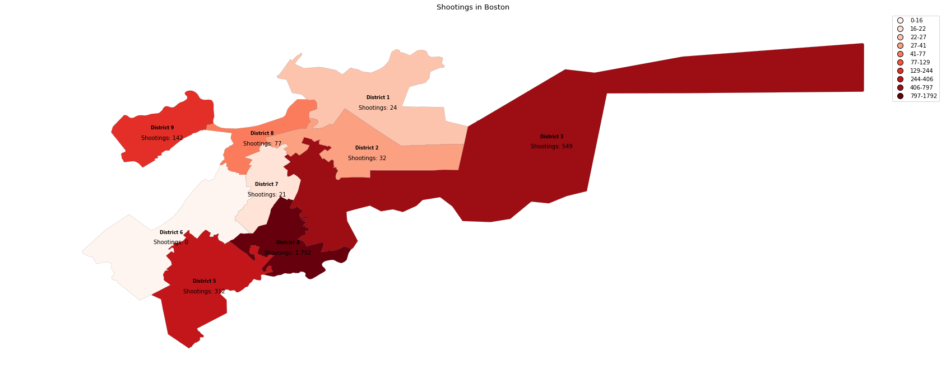

Fig. 5 District-wise intensity of gun violence w.r.t incidents count

Figure 5 shows the district-wise gun violence intensity with the help of color gradients. Every district is marked with a color based on the count of gun violence incidents in that district compared to other districts. The figure demonstrates the stark difference in the intensity of gun violence incidents in District 4 versus the rest of Boston, with 1792 in District 4 as compared to 549 in District 3, which is the second most affected district. This means there are more than thrice gun violence incidents in District 4 as compared to District 3, illustrating the importance of this project.

# Section 2 Granular-level analysis for various Gun Violence trends

### Section 2.1 Shooting Incidents by Victim Race and Gender

In Figure 6, we tried to look for patterns between the shooting victims regarding their race and gender. It is evident from this graph that Black Men are targeted the most in these shootings.

Although the number of White Men is very low compared to Black Men, this is also sufficient, and we should also try to look into it.

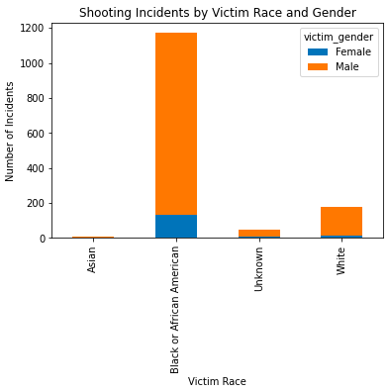

Fig. 6 Shooting Incidents by Victim Race and Gender

***Section 2.2* Average Number of Shootings per Day of the Week (District 4 vs. Other Districts)**

Figure 7 compares the Average number of shootings in District 4 vs. The other districts across 2015-2023 per day of the week. The average number of shootings in District 4 is remarkably higher than all other districts combined. We see a higher average of shootings over the weekend(Saturday and Sunday) than during weekdays.

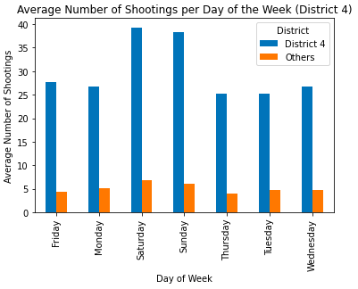

Fig. 7 ​​Average Number of Shootings per Day of the Week

### *Section 2.3* Average Number of Shootings per Day of the Week (District 4 - Police Districts)

Figure 8 delves deeper into District 4 and analyzes the data w.r.t police districts (B2,B3,C11,E5) that constitute District 4. Police District B2 is the most affected out of the 4 police districts constituting District 4. We again see the trend of a higher average of shootings over the weekend (Saturday and Sunday) than on weekdays.

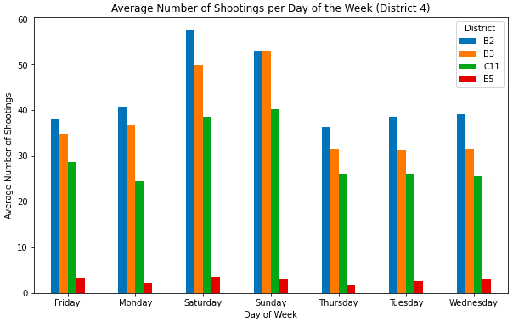

Fig. 8 ​​Average Number of Shootings per Day of the Week

### *Section 2.4* Number of Shootings per Hour in the Day from 2015 to 2023

Figure 9 explores and understands when these Gun Violence incidents happen during the day. Overall, the data support the assumption that more gun incidents happen at night rather than during the day. We can also see a lovely parabolic trend of gun violence incidents with fascinating mathematical properties that can be explored with further research. It also observed that gun violence incidents in council district 4 have the same parabolic trend as the rest of Boston, indicating nothing abnormal about gun violence incident times in District 4.

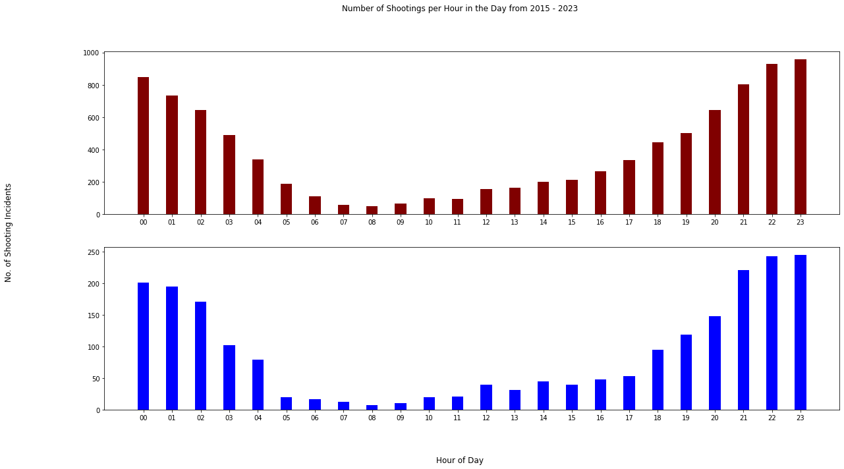

Fig. 9 ​​Number of Shootings per Hour in the Day from 2015 to 2023

### 

### *Section 2.5* Number of Fatal vs. Non-Fatal Incidents per District per Year

Figure 10 analyzes the number of fatal and non-fatal incidents. The graph is meant to compare how fatal vs. non-fatal shooting incidents in the various districts have changed over the years, given the y-axis is the same (max. 80). This is easy for the layman to observe the various trends. Except for police district B3 in 2023, the other districts have more non-fatal shooting incidents than fatal ones. This could mean that most shooting incidents were probably not targeted shootings. There are/were some districts with no fatal shootings and even negligible non-fatal shootings, e.g., district A15 in 2016, 2019, etc. Police District B2, a part of congressional district D4, has the highest number of non-fatal shooting incidents yearly, except in 2022, where B3 had the highest number, and in 2023, tied with C11, another police district under congressional district D4. Police District B3, a part of congressional district D4, has the highest number of fatal shooting incidents every year from 2018 to 2023.

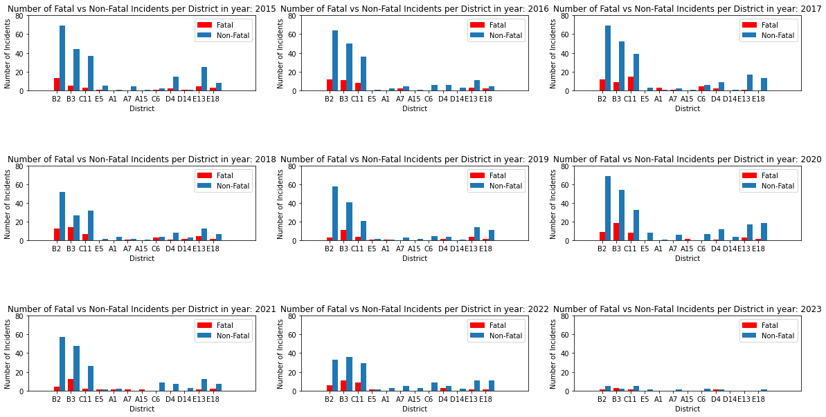

Fig. 10 Number of Fatal vs. Non-Fatal Incidents per District per Year

### *Section 2.6* Distribution of Multiple and Single Victim Incidents

Figure 11 helps us see how many of these Gun Violence incidents involved Multiple victims vs. Single Victims. We can deduce that as the number of single victims is almost double of multiple victims, this could be happening because of some targeted issue or clash between the victim and the guilty person.

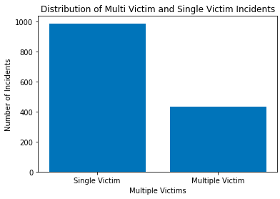

Fig. 11 Distribution of Multiple and Single Victim Incidents

### *Section 2.7* Average Number of Shooting Incidents on Holidays vs. Non-Holidays

In the following two graphs, we are trying to find any patterns between the number of incidents happening on Holidays vs. Non-Holidays. From the above graphs, we can understand that there is no significant difference between the number of incidents happening on Holidays and Non-Holidays.

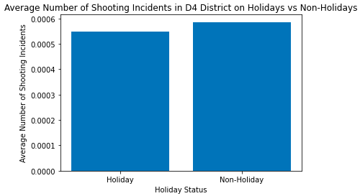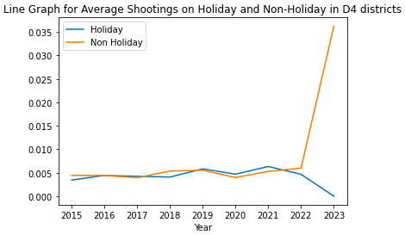

Fig. 12 Average Number of Shooting Incidents on Holidays vs. Non-Holidays

# Section 3 Extension Analysis

We wanted to look at greenery and its effect on gun violence for the extension proposal. We hypothesize that greener environments have less violence than desolate urban settings, and more gun violence incidents are closer to community centers. We want to use the extension analysis to highlight potential significant environmental trends which can pave the way for approvals for redesigning areas of Boston. The analysis might show unique trends where the environment and community settings affect gun violence more heavily than theorized.

Our team is interested in analyzing gun violence in council district 4 through different lenses to highlight unique trends that may not have been easily identified. One of our teammates is local to Boston and has visited many parks. He associated some parks with higher violence while others lower based on personal experience. As a team, we were interested in further exploring that idea. When we thought about unique situations or out of normal events/activities which could be a driver for gun violence, we realized community centers could be a potential root cause for violence driven by hate, prejudice, or revenge. This can be because of multiple factors, mainly being, community centers are places where like-minded individuals, who could potentially be strongly opinionated, come together, which in turn could turn into a breeding ground for trivial as well as consequential altercations.

### Section 3.1 Gun Violence Incidents over Parks Shapefile

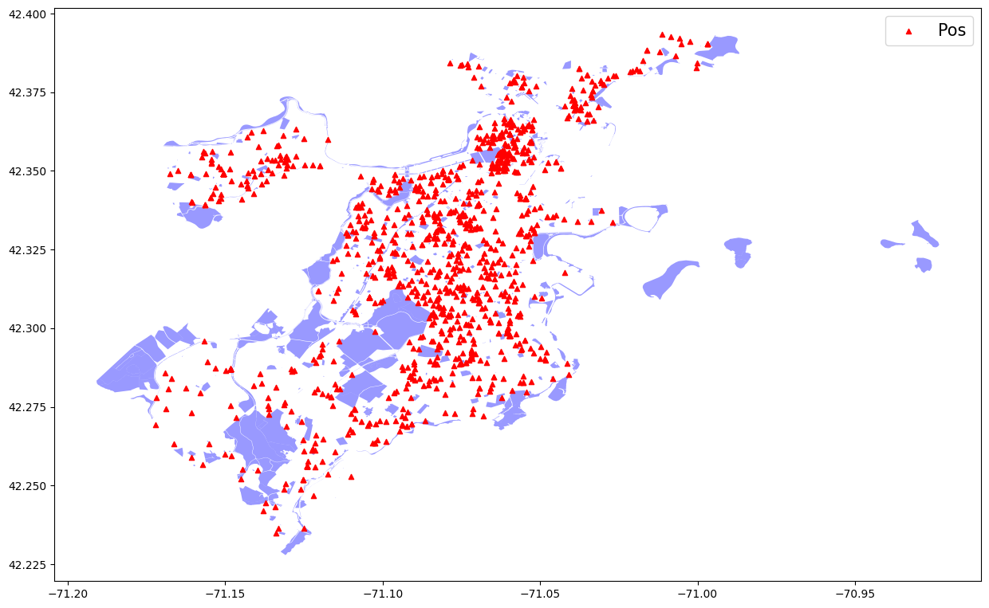

Fig. 13 Average Number of Shooting Incidents on Holidays vs. Non-Holidays

Figure 13 shows that most gun violence incidents do not happen in parks. Boston has a high park area-to-city ratio, so it is difficult to conclude if shootings happen near parks with this bias. It could also be that police reports require a street address, which is not present in parks. As such, the street addresses of the areas outside of the park may be recorded instead.

### Section 3.2 Top 10 Community Centers with Most Shootings within 1 mile radius

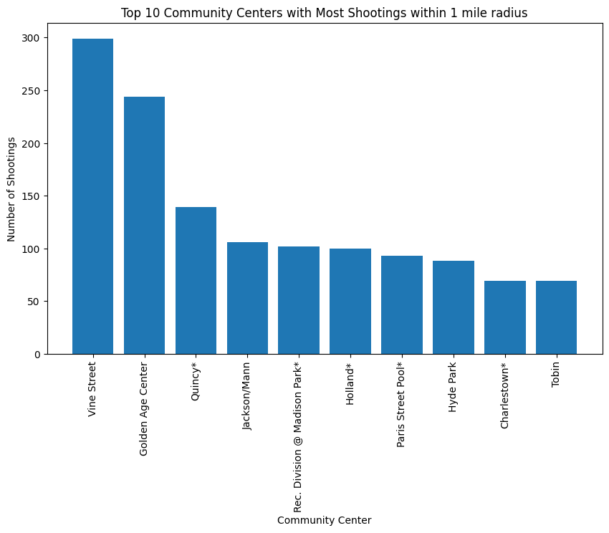

Fig. 14 Top 10 Community centers with Most Shootings within 1 mile radius

Figure 14 shows the top 10 community centers with the most shootings within a 1 mile radius. More shootings near community centers seem to happen in City Councils 1 and 7, with 3 community centers each in the top 10 list. Also, there is only one community center from City Councils 2, 4, 5, and 9 in the top 10 list.

### Section 3.3 Race Segmentation in Community Centers

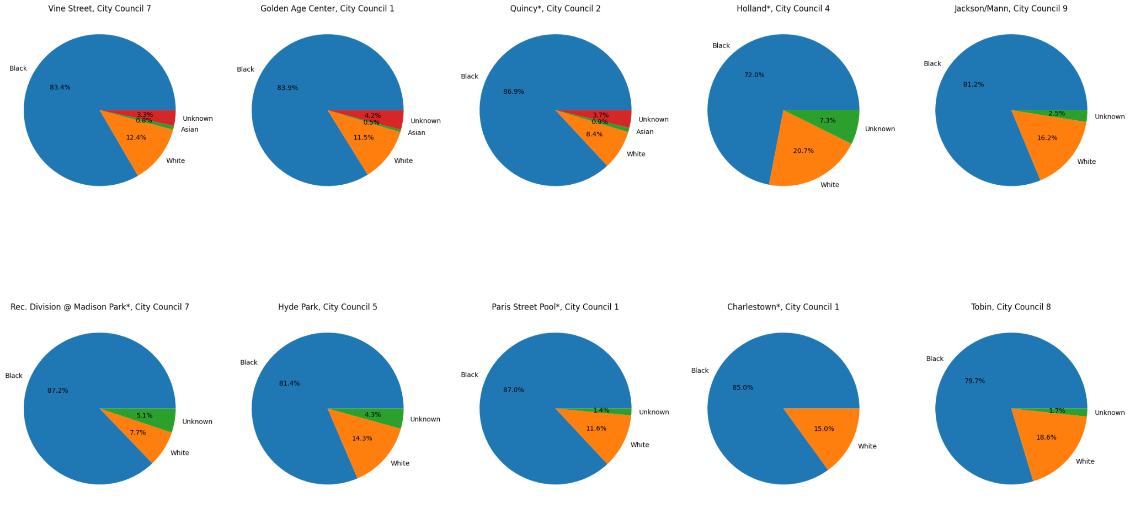

Fig. 15 Race Segmentation in Community Centers

Figure 15 shows the race segmentation in community centers through pie charts. In every community center on the top 10 list, more than 75% of the victims are Black. The community center at Holland (City Council 4) has the highest number of White and Asian victims out of the community centers in the top 10 list at 19.5% and 1.1 %, respectively.

### Section 3.4 Gender Segmentation in Community Centers

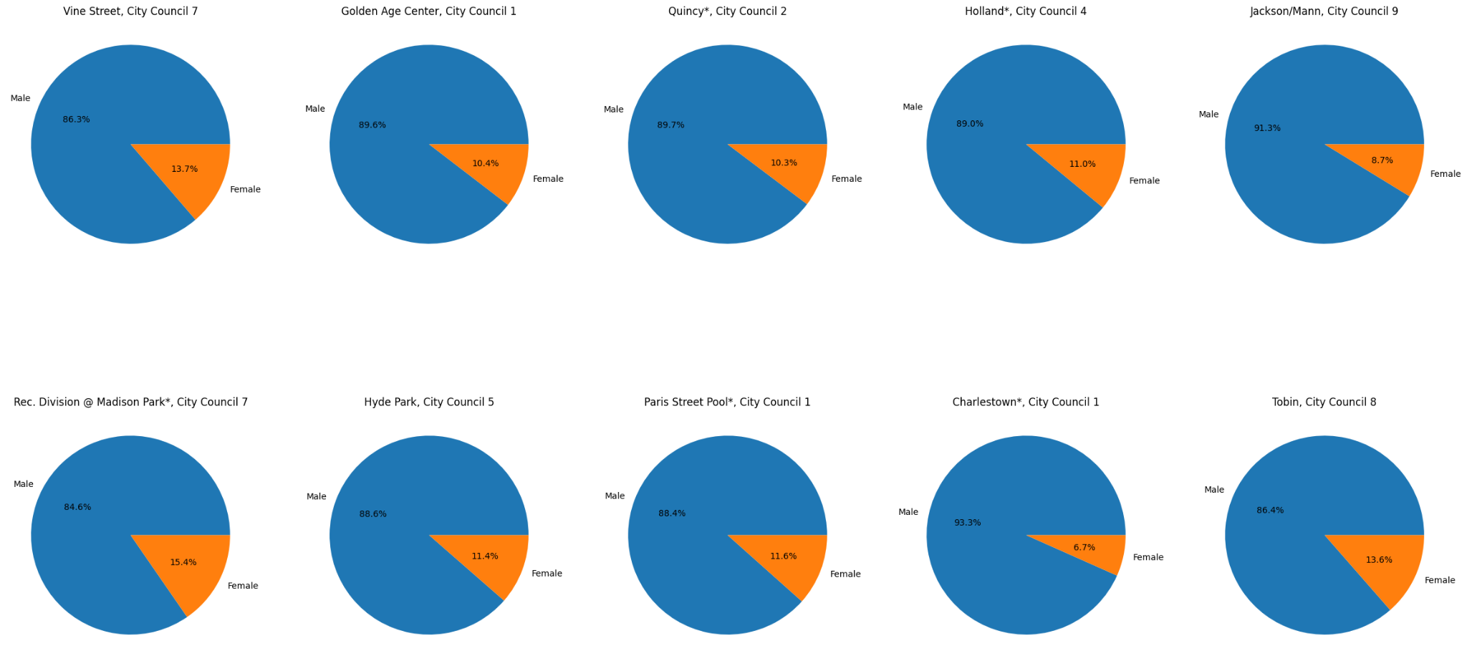

Fig. 16 Gender Segmentation in Community Centers

Figure 16 illustrates the gender segmentation in community centers through pie charts. In all the community centers on the top 10 list, there are always more male victims than female victims (more than 80% of the victims are males in every case versus more than 8% for females). Golden Age Community Center in City Council 1 has the highest percentage of male victims at 91%, whereas for females, it is at Charlestown, also in City Council 1, with 17%.

# Section 4 Team Contribution Segmentation

| **Task/Person** | **Sarah Bonna** | **Showndarya Madhavan** | **Brian Mahabir** | **Shivangi** |
| --- | --- | --- | --- | --- |
| **Get the Team Together** | **✅** |  |  |  |
| **Deliverable 0 (First Scrum Report)** | **✅** | **✅** | **✅** | **✅** |
| **Deliverable 1** |  |  |  |  |
| ***Histogram****: Rate of Gun violence in each district per year* |  |  | **✅** |  |
| ***The intensity of colo****r* ***shapefile****: city council district-wise with shootings (rate of gun violence)* |  | **✅** |  |  |
| ***Stacked Bar****: Number of victims vs districts per race* |  |  |  | **✅** |
| ***Bar****: District 4 vs the rest of Boston (rate of gun violence per year)* | **✅** |  |  |  |
| **Checkpoint A / Deliverable 2** | **Sarah Bonna** | **Showndarya Madhavan** | **Brian Mahabir** | **Shivangi** |
| *Number of Shootings per Hour in the Day from 2015 to 2023* |  |  | **✅** |  |
| *Number of Fatal vs Non-Fatal Shootings per District per Year* | **✅** |  |  |  |
| *Average number of shootings per day of the week vs district (across the years)* |  | **✅** |  |  |
| *Shooting Incidents by Victim's Race and Gender* |  |  |  | **✅** |
| *Multiple Victims vs Single Victims* |  |  |  | **✅** |
| *Shooting Incidents on Holidays and Non Holidays* |  |  |  | **✅** |
| **Checkpoint B** | **Sarah Bonna** | **Showndarya Madhavan** | **Brian Mahabir** | **Shivangi** |
| *Close proximity plots* |  |  |  | **✅** |
| *Mapped Gun violence incidents to parks shapefile* |  |  | **✅** |  |
| *Community Race and Gender Graphs* | **✅** |  |  |  |
| *Create a new dataset that relates race population with districts.* |  | **✅** |  |  |
| **Deliverable Reports and Presentations** | **✅** | **✅** | **✅** | **✅** |
| **Weekly Scrum Reports** | **✅** | **✅** | **✅** | **✅** |

# 

# Section 5 Limitations

There needs to be a precise mapping of which Boston Police Districts are mapped to which City Council Districts, so we had to approximate the mappings. This means that our analysis may not be accurate because the shooting incidents that feature predominantly appear in multiple districts instead of each incident being mapped to just 1 district.

# 

# Section 6 Conclusion

# Gun violence is a complex issue with multiple drivers, including demographic, socioeconomic, geographic, criminal justice, and gun law factors. This analysis suggests that prevention efforts should address the root causes of gun violence, such as poverty and lack of education and employment opportunities, rather than relying solely on criminal justice interventions. Additionally, enforcing strong gun laws and reducing access to firearms can reduce gun violence.

# 